# Job Aid: OneDrive Sync Verification

The legacy Hillshire HuB is moving to the Source. All OneDrive users using sync to save a local copy of your OneDrive to your computer, will need to change to source of the sync after the migration is complete. A job aid on how to change the source of your sync will be provided after migration is compelte.

## Determining if you use OneDrive Sync

To determine whether or not you are using sync, look for the cloud icon (cid:image001.png@01D0986E.BCEB34E0 ) in the bottom right hand corner of your screen. Right click on the icon and navigate to **Stop syncing a folder…**

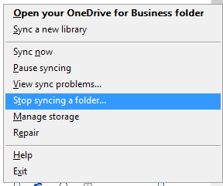

One Drive folders currently synced, will be displayed. Click **Cancel**.

